Institute Accounts and Audits (IAA) - Workflow Specifications
Basis + Composite Workflows; STT Authoritative
Status: FINAL | Version: 1.3 | Module: IAA
DIRECT_FINAL_v2 is applied. Automatic timeout escalation (IAA-UC-203) and automatic anomaly creation (IAA-UC-304) are event-triggered UCs. System appears in the STT Actor column only for those meaningful autonomous state-changing transitions. Budget/anomaly handling remains a separate anomaly lifecycle rather than being conflated with approval-timeout escalation.

Workflow Catalogue
Workflow ID | Name | Type | Constituent / Related
BW-IAA-01 | Expense/Voucher Standard Success | Basis | BW-IAA-02, BW-IAA-03, BW-IAA-04, BW-IAA-05, BW-IAA-06; CW-IAA-01
BW-IAA-02 | Expense/Voucher One Additional Approval Traversal | Basis | BW-IAA-01; CW-IAA-01
BW-IAA-03 | Expense/Voucher Rejection | Basis | CW-IAA-01
BW-IAA-04 | Expense/Voucher One Clarification Traversal | Basis | CW-IAA-01
BW-IAA-05 | Escalated Expense/Voucher Approval | Basis | BW-IAA-06; CW-IAA-01
BW-IAA-06 | Escalated Expense/Voucher Rejection | Basis | BW-IAA-05; CW-IAA-01
BW-IAA-07 | Standard TA Processing | Basis | CW-IAA-02
BW-IAA-08 | High-Value TA Approval | Basis | BW-IAA-09, BW-IAA-10, BW-IAA-16, BW-IAA-17; CW-IAA-02
BW-IAA-09 | High-Value TA One Additional Approval Traversal | Basis | BW-IAA-08; CW-IAA-02
BW-IAA-10 | High-Value TA Rejection | Basis | CW-IAA-02
BW-IAA-11 | TA One Clarification Traversal | Basis | CW-IAA-02
BW-IAA-12 | Anomaly Direct Resolution | Basis | BW-IAA-13, BW-IAA-18, BW-IAA-19; CW-IAA-03
BW-IAA-13 | Anomaly One Escalation Traversal | Basis | BW-IAA-12; CW-IAA-03
BW-IAA-14 | Audit Observation Straight Closure | Basis | BW-IAA-15; CW-IAA-04
BW-IAA-15 | Audit Observation One Revision Traversal | Basis | CW-IAA-04
BW-IAA-16 | Escalated High-Value TA Approval | Basis | BW-IAA-17; CW-IAA-02
BW-IAA-17 | Escalated High-Value TA Rejection | Basis | BW-IAA-16; CW-IAA-02
BW-IAA-18 | Automatic Anomaly Direct Resolution | Basis | BW-IAA-19, BW-IAA-12, BW-IAA-13; CW-IAA-03
BW-IAA-19 | Automatic Anomaly One Escalation Traversal | Basis | BW-IAA-18; CW-IAA-03
CW-IAA-01 | Expense/Voucher Lifecycle | Composite | BW-IAA-01 through BW-IAA-06
CW-IAA-02 | TA Lifecycle | Composite | BW-IAA-07 through BW-IAA-11; BW-IAA-16; BW-IAA-17
CW-IAA-03 | Anomaly Lifecycle | Composite | BW-IAA-12, BW-IAA-13, BW-IAA-18, BW-IAA-19
CW-IAA-04 | Audit Observation Lifecycle | Composite | BW-IAA-14, BW-IAA-15

BW-IAA-01 - Expense/Voucher Standard Success
Field | Specification
Workflow ID | BW-IAA-01
Workflow Name | Expense/Voucher Standard Success
Type | Basis
Purpose / Scope | One-level expense/voucher success path from creation to recorded completion.
Trigger | Basic User starts a new request.
Participants | Basic User; Finance Staff; Assigned Approving Authority
Constituent Workflows | N/A
Related Workflows | BW-IAA-02, BW-IAA-03, BW-IAA-04, BW-IAA-05, BW-IAA-06; CW-IAA-01
Related CFRs / key AFRs
Related UCs | IAA-UC-101, IAA-UC-102, IAA-UC-103, IAA-UC-201, IAA-UC-105
Related BRs | IAA-BR-101, IAA-BR-503, IAA-BR-104, IAA-BR-102, IAA-BR-001, IAA-BR-002, IAA-BR-005, IAA-BR-006
Traceability | See final CFR/AFR RTM for exact row-level requirement mapping. State-Transition Table below is authoritative.

Authoritative State-Transition Table
S. No. | From State | Actor | Use Case ID / Name | Guard / Outcome | Resulting State | BR Reference(s)
1 | Not Created | Basic User | IAA-UC-101 Create Expense/Voucher Request | Draft saved | Draft | IAA-BR-101, IAA-BR-503
2 | Draft | Basic User | IAA-UC-102 Submit Expense/Voucher Request | Submission complete | Submitted | IAA-BR-101, IAA-BR-104
3 | Submitted | Finance Staff | IAA-UC-103 Review & Validate Request | Validation passes | Finance Validated | IAA-BR-102
4 | Finance Validated | Assigned Approving Authority | IAA-UC-201 Approve/Reject Request | Approved; no further level required | Approved | IAA-BR-001, IAA-BR-002, IAA-BR-005
5 | Approved | Finance Staff | IAA-UC-105 Process & Record Approved Request | Internal processing complete | Recorded | IAA-BR-006, IAA-BR-503

Workflow Diagram
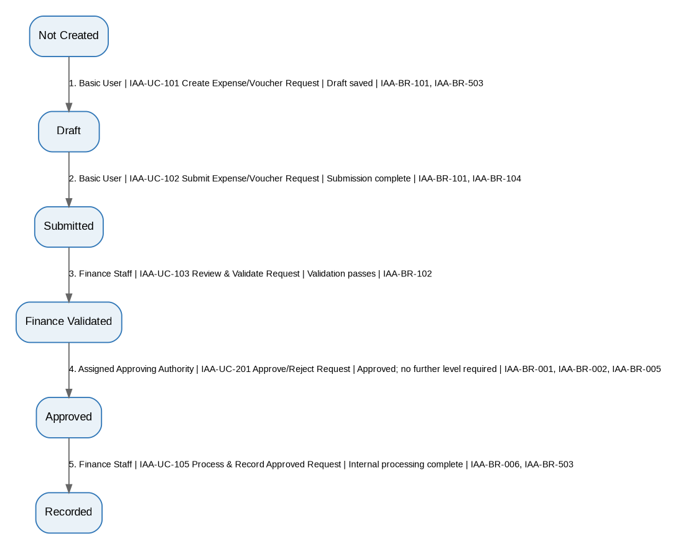
Editable source: 05A_IAA_Workflow_Diagrams_v1.3_FINAL.drawio, page BW-IAA-01. The diagram is generated from the authoritative STT above.

BW-IAA-02 - Expense/Voucher One Additional Approval Traversal
Field | Specification
Workflow ID | BW-IAA-02
Workflow Name | Expense/Voucher One Additional Approval Traversal
Type | Basis
Purpose / Scope | Representative one-traversal approval-loop path when another configured approval level is required.
Trigger | Basic User starts a request that requires at least two configured approval levels.
Participants | Basic User; Finance Staff; First Approving Authority; Next Approving Authority
Constituent Workflows | N/A
Related Workflows | BW-IAA-01; CW-IAA-01
Related CFRs / key AFRs
Related UCs | IAA-UC-101, IAA-UC-102, IAA-UC-103, IAA-UC-201, IAA-UC-105
Related BRs | IAA-BR-101, IAA-BR-102, IAA-BR-001, IAA-BR-002, IAA-BR-005, IAA-BR-006, IAA-BR-503
Traceability | See final CFR/AFR RTM for exact row-level requirement mapping. State-Transition Table below is authoritative.

Authoritative State-Transition Table
S. No. | From State | Actor | Use Case ID / Name | Guard / Outcome | Resulting State | BR Reference(s)
1 | Not Created | Basic User | IAA-UC-101 Create Expense/Voucher Request | Draft saved | Draft | IAA-BR-101
2 | Draft | Basic User | IAA-UC-102 Submit Expense/Voucher Request | Submission complete | Submitted | IAA-BR-101
3 | Submitted | Finance Staff | IAA-UC-103 Review & Validate Request | Validation passes | Finance Validated | IAA-BR-102
4 | Finance Validated | First Assigned Approving Authority | IAA-UC-201 Approve/Reject Request | Approved; another level required | Approval Pending | IAA-BR-001, IAA-BR-002, IAA-BR-005
5 | Approval Pending | Next Assigned Approving Authority | IAA-UC-201 Approve/Reject Request | Approved; no further level required | Approved | IAA-BR-001, IAA-BR-002, IAA-BR-005
6 | Approved | Finance Staff | IAA-UC-105 Process & Record Approved Request | Internal processing complete | Recorded | IAA-BR-006, IAA-BR-503

Workflow Diagram
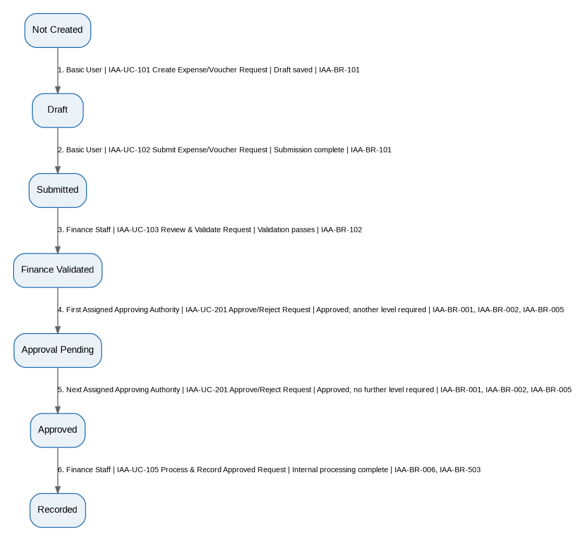
Editable source: 05A_IAA_Workflow_Diagrams_v1.3_FINAL.drawio, page BW-IAA-02. The diagram is generated from the authoritative STT above.

BW-IAA-03 - Expense/Voucher Rejection
Field | Specification
Workflow ID | BW-IAA-03
Workflow Name | Expense/Voucher Rejection
Type | Basis
Purpose / Scope | Expense/voucher path ending in authority rejection.
Trigger | Basic User starts a request that reaches authority decision.
Participants | Basic User; Finance Staff; Assigned Approving Authority
Constituent Workflows | N/A
Related Workflows | CW-IAA-01
Related CFRs / key AFRs
Related UCs | IAA-UC-101, IAA-UC-102, IAA-UC-103, IAA-UC-201
Related BRs | IAA-BR-101, IAA-BR-102, IAA-BR-001, IAA-BR-002, IAA-BR-005
Traceability | See final CFR/AFR RTM for exact row-level requirement mapping. State-Transition Table below is authoritative.

Authoritative State-Transition Table
S. No. | From State | Actor | Use Case ID / Name | Guard / Outcome | Resulting State | BR Reference(s)
1 | Not Created | Basic User | IAA-UC-101 Create Expense/Voucher Request | Draft saved | Draft | IAA-BR-101
2 | Draft | Basic User | IAA-UC-102 Submit Expense/Voucher Request | Submission complete | Submitted | IAA-BR-101
3 | Submitted | Finance Staff | IAA-UC-103 Review & Validate Request | Validation passes | Finance Validated | IAA-BR-102
4 | Finance Validated | Assigned Approving Authority | IAA-UC-201 Approve/Reject Request | Rejected with remarks | Rejected | IAA-BR-001, IAA-BR-002, IAA-BR-005

Workflow Diagram
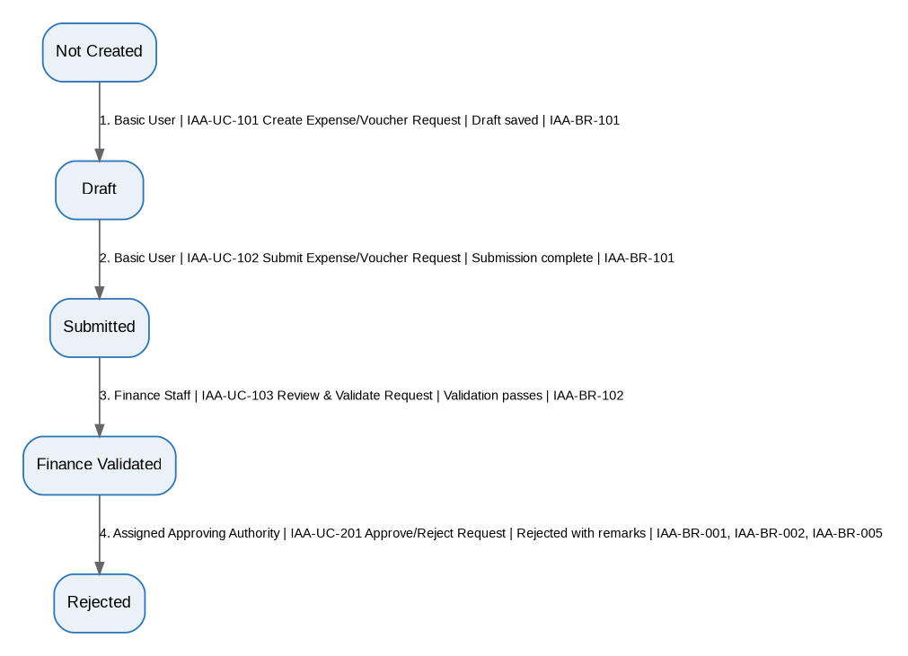
Editable source: 05A_IAA_Workflow_Diagrams_v1.3_FINAL.drawio, page BW-IAA-03. The diagram is generated from the authoritative STT above.

BW-IAA-04 - Expense/Voucher One Clarification Traversal
Field | Specification
Workflow ID | BW-IAA-04
Workflow Name | Expense/Voucher One Clarification Traversal
Type | Basis
Purpose / Scope | Representative one-traversal Finance clarification loop followed by successful one-level approval.
Trigger | Finance requires clarification on a Submitted request.
Participants | Basic User; Finance Staff; Assigned Approving Authority
Constituent Workflows | N/A
Related Workflows | CW-IAA-01
Related CFRs / key AFRs
Related UCs | IAA-UC-103, IAA-UC-104, IAA-UC-201, IAA-UC-105
Related BRs | IAA-BR-504, IAA-BR-104, IAA-BR-503, IAA-BR-102, IAA-BR-001, IAA-BR-002, IAA-BR-005, IAA-BR-006
Traceability | See final CFR/AFR RTM for exact row-level requirement mapping. State-Transition Table below is authoritative.

Authoritative State-Transition Table
S. No. | From State | Actor | Use Case ID / Name | Guard / Outcome | Resulting State | BR Reference(s)
1 | Submitted | Finance Staff | IAA-UC-103 Review & Validate Request | Clarification required | Query Raised | IAA-BR-504
2 | Query Raised | Basic User | IAA-UC-104 Respond to Finance Clarification Query | Response complete | Query Responded | IAA-BR-104, IAA-BR-503
3 | Query Responded | Finance Staff | IAA-UC-103 Review & Validate Request | Validation passes after response | Finance Validated | IAA-BR-102
4 | Finance Validated | Assigned Approving Authority | IAA-UC-201 Approve/Reject Request | Approved; no further level required | Approved | IAA-BR-001, IAA-BR-002, IAA-BR-005
5 | Approved | Finance Staff | IAA-UC-105 Process & Record Approved Request | Internal processing complete | Recorded | IAA-BR-006, IAA-BR-503

Workflow Diagram
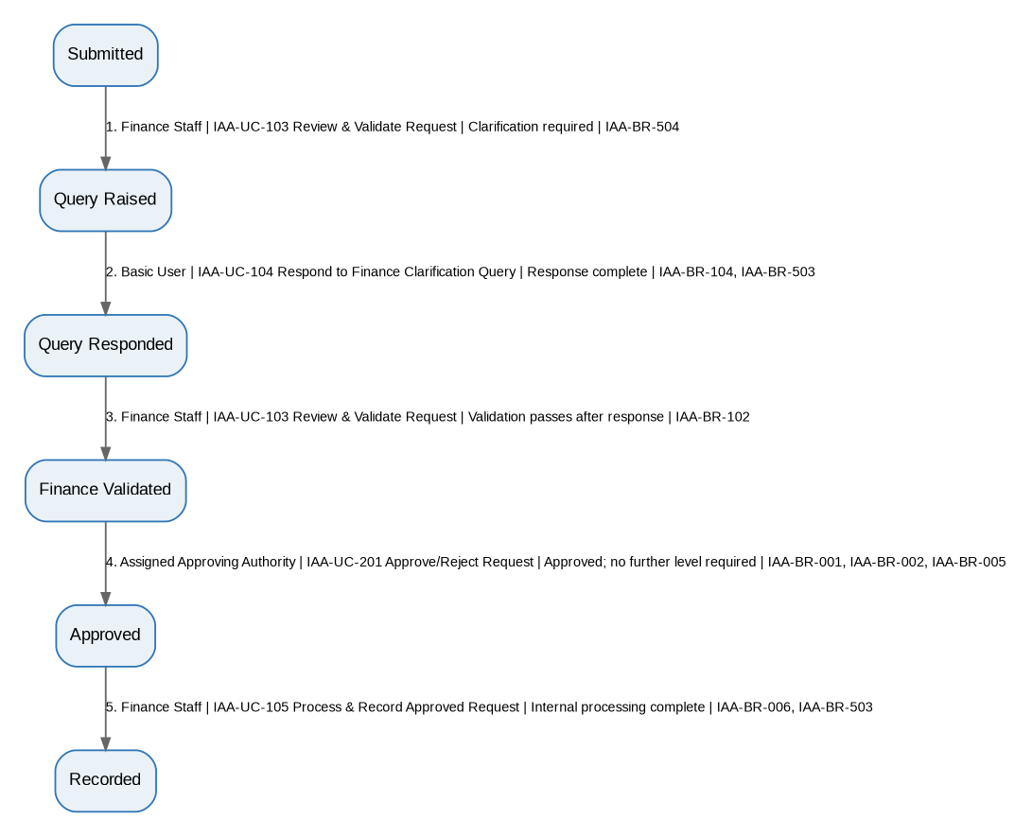
Editable source: 05A_IAA_Workflow_Diagrams_v1.3_FINAL.drawio, page BW-IAA-04. The diagram is generated from the authoritative STT above.

BW-IAA-05 - Escalated Expense/Voucher Approval
Field | Specification
Workflow ID | BW-IAA-05
Workflow Name | Escalated Expense/Voucher Approval
Type | Basis
Purpose / Scope | One timeout traversal from pending expense/voucher approval to escalation, higher-authority approval, and recorded completion.
Trigger | Configured approval action time limit expires for a pending expense/voucher authority decision.
Participants | System (automatic transition); Next/Higher Assigned Approving Authority; Finance Staff
Constituent Workflows | N/A
Related Workflows | BW-IAA-06; CW-IAA-01
Related CFRs / key AFRs
Related UCs | IAA-UC-203, IAA-UC-202, IAA-UC-105
Related BRs | IAA-BR-001, IAA-BR-002, IAA-BR-401, IAA-BR-005, IAA-BR-006, IAA-BR-503
Traceability | See final CFR/AFR RTM for exact row-level requirement mapping. State-Transition Table below is authoritative.

Authoritative State-Transition Table
S. No. | From State | Actor | Use Case ID / Name | Guard / Outcome | Resulting State | BR Reference(s)
1 | Finance Validated or Approval Pending | System | IAA-UC-203 Escalate Overdue Approval | Pending authority action exceeds configured time limit | Escalated | IAA-BR-001, IAA-BR-002, IAA-BR-401
2 | Escalated | Next/Higher Assigned Approving Authority | IAA-UC-202 Handle Escalated Approval | Approved; no further approval level required | Approved | IAA-BR-001, IAA-BR-002, IAA-BR-005, IAA-BR-401
3 | Approved | Finance Staff | IAA-UC-105 Process & Record Approved Request | Internal processing complete | Recorded | IAA-BR-006, IAA-BR-503

Workflow Diagram
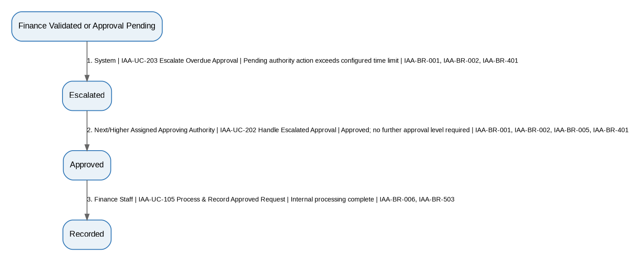
Editable source: 05A_IAA_Workflow_Diagrams_v1.3_FINAL.drawio, page BW-IAA-05. The diagram is generated from the authoritative STT above.

BW-IAA-06 - Escalated Expense/Voucher Rejection
Field | Specification
Workflow ID | BW-IAA-06
Workflow Name | Escalated Expense/Voucher Rejection
Type | Basis
Purpose / Scope | One timeout traversal from pending expense/voucher approval to escalation and higher-authority rejection.
Trigger | Configured approval action time limit expires for a pending expense/voucher authority decision.
Participants | System (automatic transition); Next/Higher Assigned Approving Authority
Constituent Workflows | N/A
Related Workflows | BW-IAA-05; CW-IAA-01
Related CFRs / key AFRs
Related UCs | IAA-UC-203, IAA-UC-202
Related BRs | IAA-BR-001, IAA-BR-002, IAA-BR-401, IAA-BR-005
Traceability | See final CFR/AFR RTM for exact row-level requirement mapping. State-Transition Table below is authoritative.

Authoritative State-Transition Table
S. No. | From State | Actor | Use Case ID / Name | Guard / Outcome | Resulting State | BR Reference(s)
1 | Finance Validated or Approval Pending | System | IAA-UC-203 Escalate Overdue Approval | Pending authority action exceeds configured time limit | Escalated | IAA-BR-001, IAA-BR-002, IAA-BR-401
2 | Escalated | Next/Higher Assigned Approving Authority | IAA-UC-202 Handle Escalated Approval | Rejected with remarks | Rejected | IAA-BR-001, IAA-BR-002, IAA-BR-005, IAA-BR-401

Workflow Diagram
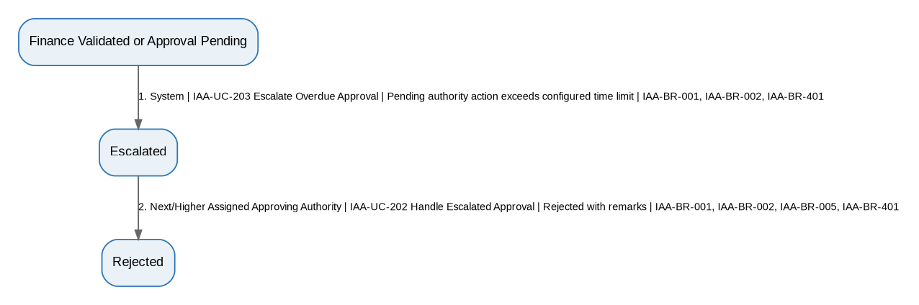
Editable source: 05A_IAA_Workflow_Diagrams_v1.3_FINAL.drawio, page BW-IAA-06. The diagram is generated from the authoritative STT above.

BW-IAA-07 - Standard TA Processing
Field | Specification
Workflow ID | BW-IAA-07
Workflow Name | Standard TA Processing
Type | Basis
Purpose / Scope | Standard TA claim path requiring no authority approval.
Trigger | Eligible employee submits a TA claim.
Participants | Basic User (Employee); Finance Staff
Constituent Workflows | N/A
Related Workflows | CW-IAA-02
Related CFRs / key AFRs
Related UCs | IAA-UC-401, IAA-UC-402, IAA-UC-404
Related BRs | IAA-BR-101, IAA-BR-102, IAA-BR-201, IAA-BR-202, IAA-BR-006, IAA-BR-503
Traceability | See final CFR/AFR RTM for exact row-level requirement mapping. State-Transition Table below is authoritative.

Authoritative State-Transition Table
S. No. | From State | Actor | Use Case ID / Name | Guard / Outcome | Resulting State | BR Reference(s)
1 | Not Submitted | Basic User (Employee) | IAA-UC-401 Submit TA Form | Submission valid | Submitted | IAA-BR-101
2 | Submitted | Finance Staff | IAA-UC-402 Verify TA Form | Verified; high-value approval not required | Verified | IAA-BR-102, IAA-BR-201, IAA-BR-202
3 | Verified | Finance Staff | IAA-UC-404 Process & Record TA Request | Internal processing complete | Recorded | IAA-BR-006, IAA-BR-503

Workflow Diagram
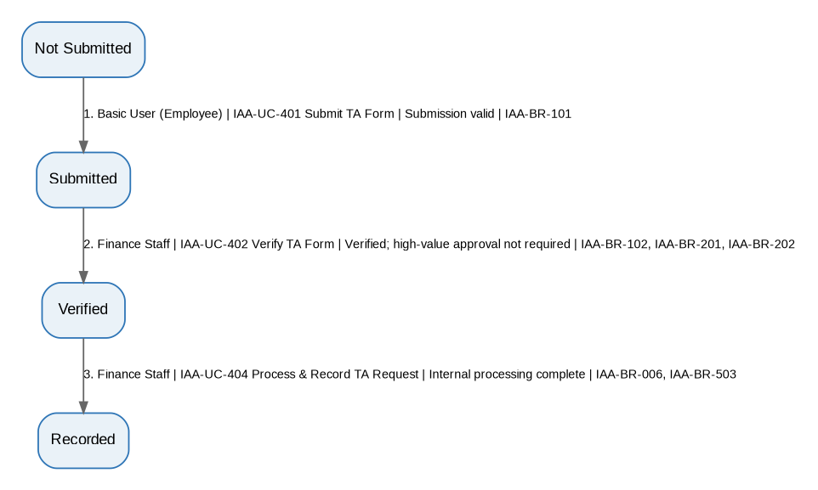
Editable source: 05A_IAA_Workflow_Diagrams_v1.3_FINAL.drawio, page BW-IAA-07. The diagram is generated from the authoritative STT above.

BW-IAA-08 - High-Value TA Approval
Field | Specification
Workflow ID | BW-IAA-08
Workflow Name | High-Value TA Approval
Type | Basis
Purpose / Scope | High-value TA success path with one authority level.
Trigger | Eligible employee submits a TA claim that requires authority approval.
Participants | Basic User (Employee); Finance Staff; Assigned Approving Authority
Constituent Workflows | N/A
Related Workflows | BW-IAA-09, BW-IAA-10, BW-IAA-16, BW-IAA-17; CW-IAA-02
Related CFRs / key AFRs
Related UCs | IAA-UC-401, IAA-UC-402, IAA-UC-403, IAA-UC-404
Related BRs | IAA-BR-101, IAA-BR-102, IAA-BR-201, IAA-BR-202, IAA-BR-001, IAA-BR-002, IAA-BR-005, IAA-BR-006, IAA-BR-503
Traceability | See final CFR/AFR RTM for exact row-level requirement mapping. State-Transition Table below is authoritative.

Authoritative State-Transition Table
S. No. | From State | Actor | Use Case ID / Name | Guard / Outcome | Resulting State | BR Reference(s)
1 | Not Submitted | Basic User (Employee) | IAA-UC-401 Submit TA Form | Submission valid | Submitted | IAA-BR-101
2 | Submitted | Finance Staff | IAA-UC-402 Verify TA Form | Verified; high-value approval required | Approval Pending | IAA-BR-102, IAA-BR-201, IAA-BR-202
3 | Approval Pending | Assigned Approving Authority | IAA-UC-403 Approve/Reject High-Value TA | Approved; no further level required | Approved | IAA-BR-001, IAA-BR-002, IAA-BR-005, IAA-BR-202
4 | Approved | Finance Staff | IAA-UC-404 Process & Record TA Request | Internal processing complete | Recorded | IAA-BR-006, IAA-BR-503

Workflow Diagram
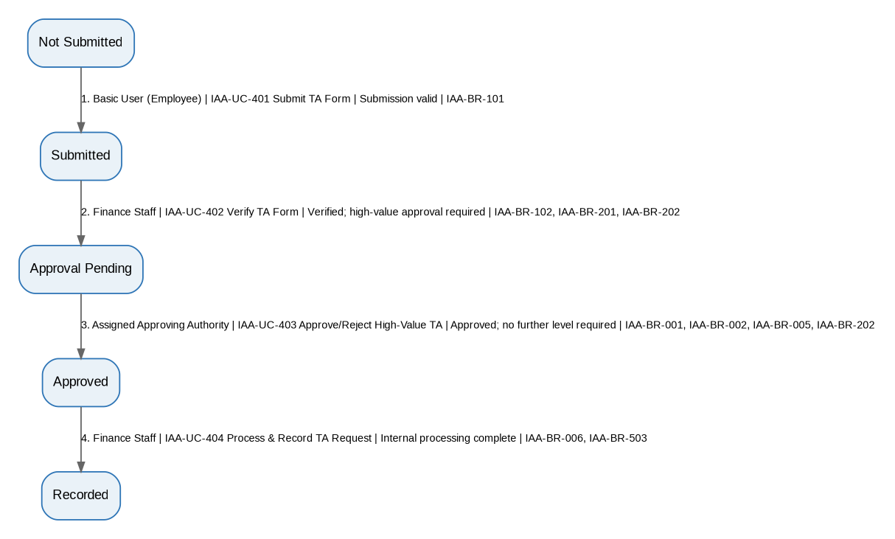
Editable source: 05A_IAA_Workflow_Diagrams_v1.3_FINAL.drawio, page BW-IAA-08. The diagram is generated from the authoritative STT above.

BW-IAA-09 - High-Value TA One Additional Approval Traversal
Field | Specification
Workflow ID | BW-IAA-09
Workflow Name | High-Value TA One Additional Approval Traversal
Type | Basis
Purpose / Scope | Representative one-traversal additional approval level for a high-value TA claim.
Trigger | High-value TA claim requires at least two configured approval levels.
Participants | Basic User (Employee); Finance Staff; First Approving Authority; Next Approving Authority
Constituent Workflows | N/A
Related Workflows | BW-IAA-08; CW-IAA-02
Related CFRs / key AFRs
Related UCs | IAA-UC-401, IAA-UC-402, IAA-UC-403, IAA-UC-404
Related BRs | IAA-BR-101, IAA-BR-102, IAA-BR-201, IAA-BR-202, IAA-BR-001, IAA-BR-002, IAA-BR-005, IAA-BR-006, IAA-BR-503
Traceability | See final CFR/AFR RTM for exact row-level requirement mapping. State-Transition Table below is authoritative.

Authoritative State-Transition Table
S. No. | From State | Actor | Use Case ID / Name | Guard / Outcome | Resulting State | BR Reference(s)
1 | Not Submitted | Basic User (Employee) | IAA-UC-401 Submit TA Form | Submission valid | Submitted | IAA-BR-101
2 | Submitted | Finance Staff | IAA-UC-402 Verify TA Form | Verified; approval required | Approval Pending | IAA-BR-102, IAA-BR-201, IAA-BR-202
3 | Approval Pending | First Assigned Approving Authority | IAA-UC-403 Approve/Reject High-Value TA | Approved; another level required | Approval Pending | IAA-BR-001, IAA-BR-002, IAA-BR-005
4 | Approval Pending | Next Assigned Approving Authority | IAA-UC-403 Approve/Reject High-Value TA | Approved; no further level required | Approved | IAA-BR-001, IAA-BR-002, IAA-BR-005
5 | Approved | Finance Staff | IAA-UC-404 Process & Record TA Request | Internal processing complete | Recorded | IAA-BR-006, IAA-BR-503

Workflow Diagram
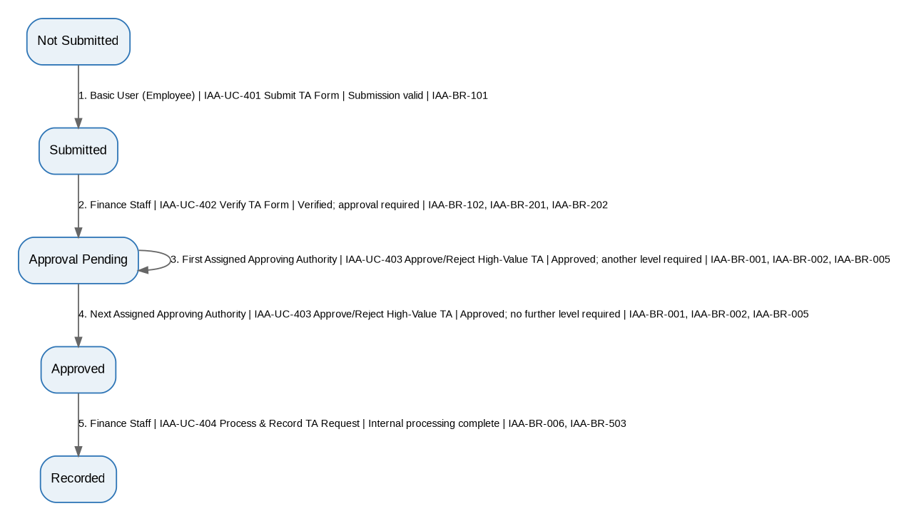
Editable source: 05A_IAA_Workflow_Diagrams_v1.3_FINAL.drawio, page BW-IAA-09. The diagram is generated from the authoritative STT above.

BW-IAA-10 - High-Value TA Rejection
Field | Specification
Workflow ID | BW-IAA-10
Workflow Name | High-Value TA Rejection
Type | Basis
Purpose / Scope | High-value TA path ending in authority rejection.
Trigger | High-value TA claim reaches authority decision.
Participants | Basic User (Employee); Finance Staff; Assigned Approving Authority
Constituent Workflows | N/A
Related Workflows | CW-IAA-02
Related CFRs / key AFRs
Related UCs | IAA-UC-401, IAA-UC-402, IAA-UC-403
Related BRs | IAA-BR-101, IAA-BR-102, IAA-BR-201, IAA-BR-202, IAA-BR-001, IAA-BR-005
Traceability | See final CFR/AFR RTM for exact row-level requirement mapping. State-Transition Table below is authoritative.

Authoritative State-Transition Table
S. No. | From State | Actor | Use Case ID / Name | Guard / Outcome | Resulting State | BR Reference(s)
1 | Not Submitted | Basic User (Employee) | IAA-UC-401 Submit TA Form | Submission valid | Submitted | IAA-BR-101
2 | Submitted | Finance Staff | IAA-UC-402 Verify TA Form | Verified; approval required | Approval Pending | IAA-BR-102, IAA-BR-201, IAA-BR-202
3 | Approval Pending | Assigned Approving Authority | IAA-UC-403 Approve/Reject High-Value TA | Rejected with remarks | Rejected | IAA-BR-001, IAA-BR-005

Workflow Diagram
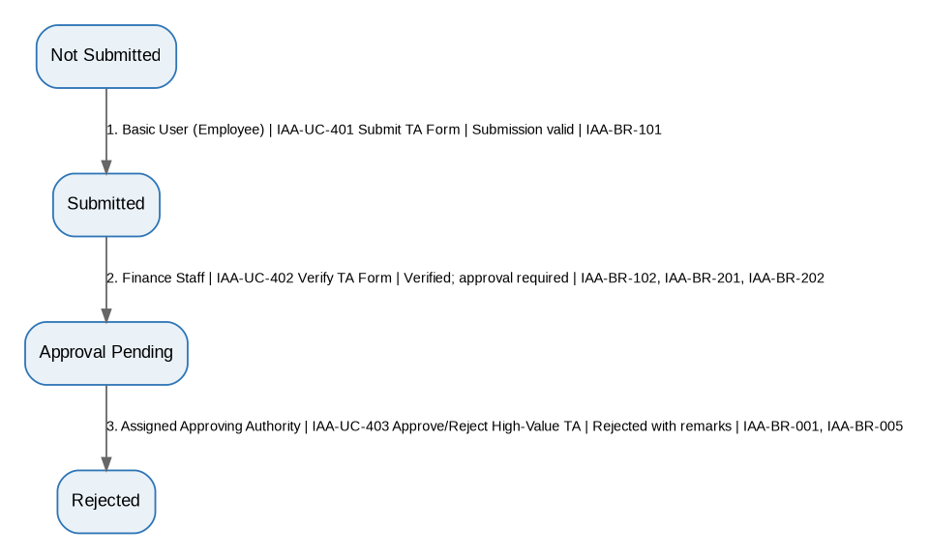
Editable source: 05A_IAA_Workflow_Diagrams_v1.3_FINAL.drawio, page BW-IAA-10. The diagram is generated from the authoritative STT above.

BW-IAA-11 - TA One Clarification Traversal
Field | Specification
Workflow ID | BW-IAA-11
Workflow Name | TA One Clarification Traversal
Type | Basis
Purpose / Scope | Representative one-traversal Finance clarification loop for a TA claim followed by standard processing.
Trigger | Finance requires clarification on a submitted TA claim.
Participants | Basic User (Employee); Finance Staff
Constituent Workflows | N/A
Related Workflows | CW-IAA-02
Related CFRs / key AFRs
Related UCs | IAA-UC-402, IAA-UC-104, IAA-UC-404
Related BRs | IAA-BR-201, IAA-BR-504, IAA-BR-104, IAA-BR-503, IAA-BR-102, IAA-BR-202, IAA-BR-006
Traceability | See final CFR/AFR RTM for exact row-level requirement mapping. State-Transition Table below is authoritative.

Authoritative State-Transition Table
S. No. | From State | Actor | Use Case ID / Name | Guard / Outcome | Resulting State | BR Reference(s)
1 | Submitted | Finance Staff | IAA-UC-402 Verify TA Form | Clarification required | Query Raised | IAA-BR-201, IAA-BR-504
2 | Query Raised | Basic User (Employee) | IAA-UC-104 Respond to Finance Clarification Query | Response complete | Query Responded | IAA-BR-104, IAA-BR-503
3 | Query Responded | Finance Staff | IAA-UC-402 Verify TA Form | Verified; no authority approval required | Verified | IAA-BR-102, IAA-BR-201, IAA-BR-202
4 | Verified | Finance Staff | IAA-UC-404 Process & Record TA Request | Internal processing complete | Recorded | IAA-BR-006, IAA-BR-503

Workflow Diagram
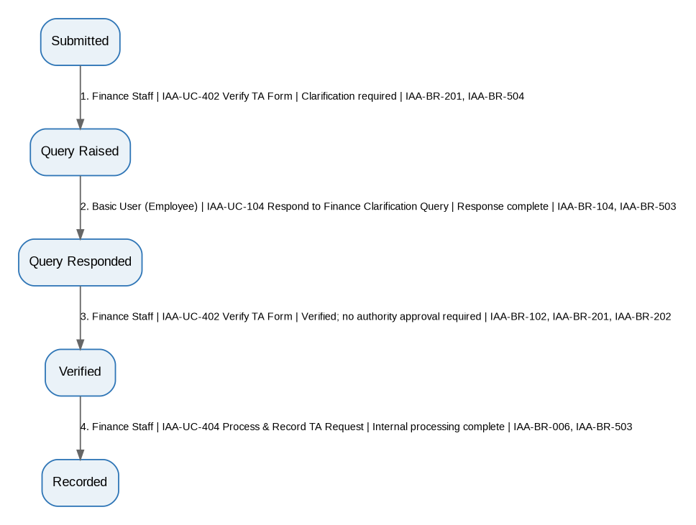
Editable source: 05A_IAA_Workflow_Diagrams_v1.3_FINAL.drawio, page BW-IAA-11. The diagram is generated from the authoritative STT above.

BW-IAA-12 - Anomaly Direct Resolution
Field | Specification
Workflow ID | BW-IAA-12
Workflow Name | Anomaly Direct Resolution
Type | Basis
Purpose / Scope | Manual material anomaly creation followed by direct resolution.
Trigger | Finance Staff or Auditor manually flags a material anomaly.
Participants | Finance Staff/Auditor; Designated Anomaly Resolver
Constituent Workflows | N/A
Related Workflows | BW-IAA-13, BW-IAA-18, BW-IAA-19; CW-IAA-03
Related CFRs / key AFRs
Related UCs | IAA-UC-302, IAA-UC-303
Related BRs | IAA-BR-103
Traceability | See final CFR/AFR RTM for exact row-level requirement mapping. State-Transition Table below is authoritative.

Authoritative State-Transition Table
S. No. | From State | Actor | Use Case ID / Name | Guard / Outcome | Resulting State | BR Reference(s)
1 | No Anomaly | Finance Staff or Auditor | IAA-UC-302 Flag Anomaly | Material anomaly confirmed | Open | IAA-BR-103
2 | Open | Designated Anomaly Resolver | IAA-UC-303 Resolve or Escalate Anomaly | Resolved | Resolved | IAA-BR-103

Workflow Diagram
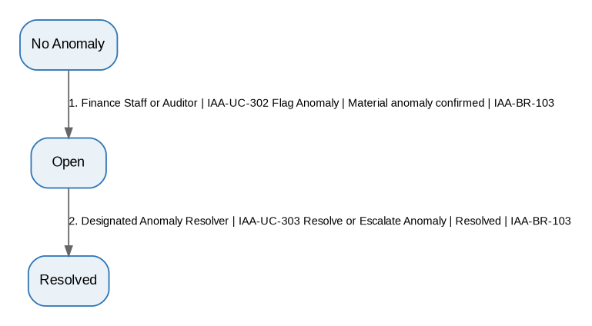
Editable source: 05A_IAA_Workflow_Diagrams_v1.3_FINAL.drawio, page BW-IAA-12. The diagram is generated from the authoritative STT above.

BW-IAA-13 - Anomaly One Escalation Traversal
Field | Specification
Workflow ID | BW-IAA-13
Workflow Name | Anomaly One Escalation Traversal
Type | Basis
Purpose / Scope | Manual material anomaly creation followed by one escalation traversal and resolution.
Trigger | Finance Staff or Auditor manually flags a material anomaly requiring higher/designated resolution.
Participants | Finance Staff/Auditor; Initial Resolver; Next Resolver
Constituent Workflows | N/A
Related Workflows | BW-IAA-12; CW-IAA-03
Related CFRs / key AFRs
Related UCs | IAA-UC-302, IAA-UC-303
Related BRs | IAA-BR-103
Traceability | See final CFR/AFR RTM for exact row-level requirement mapping. State-Transition Table below is authoritative.

Authoritative State-Transition Table
S. No. | From State | Actor | Use Case ID / Name | Guard / Outcome | Resulting State | BR Reference(s)
1 | No Anomaly | Finance Staff or Auditor | IAA-UC-302 Flag Anomaly | Material anomaly confirmed | Open | IAA-BR-103
2 | Open | Initial Designated Resolver | IAA-UC-303 Resolve or Escalate Anomaly | Further escalation required | Escalated | IAA-BR-103
3 | Escalated | Next Designated Resolver | IAA-UC-303 Resolve or Escalate Anomaly | Resolved | Resolved | IAA-BR-103

Workflow Diagram
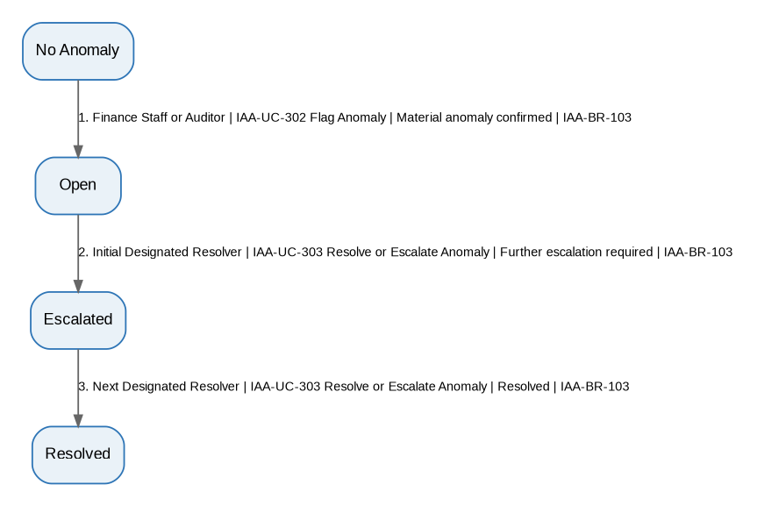
Editable source: 05A_IAA_Workflow_Diagrams_v1.3_FINAL.drawio, page BW-IAA-13. The diagram is generated from the authoritative STT above.

BW-IAA-14 - Audit Observation Straight Closure
Field | Specification
Workflow ID | BW-IAA-14
Workflow Name | Audit Observation Straight Closure
Type | Basis
Purpose / Scope | Audit observation is raised, answered once, verified, and closed.
Trigger | Auditor raises an audit observation.
Participants | Auditor; Basic User/Department Representative
Constituent Workflows | N/A
Related Workflows | BW-IAA-15; CW-IAA-04
Related CFRs / key AFRs
Related UCs | IAA-UC-501, IAA-UC-502, IAA-UC-503
Related BRs | IAA-BR-301, IAA-BR-302
Traceability | See final CFR/AFR RTM for exact row-level requirement mapping. State-Transition Table below is authoritative.

Authoritative State-Transition Table
S. No. | From State | Actor | Use Case ID / Name | Guard / Outcome | Resulting State | BR Reference(s)
1 | No Observation | Auditor | IAA-UC-501 Raise Audit Observation | Observation created | Open | IAA-BR-301
2 | Open | Basic User / Department Representative | IAA-UC-502 Respond to Audit Observation | Response/evidence submitted | Responded | IAA-BR-301
3 | Responded | Auditor | IAA-UC-503 Review and Close Audit Observation | Verification satisfactory | Closed | IAA-BR-301, IAA-BR-302

Workflow Diagram
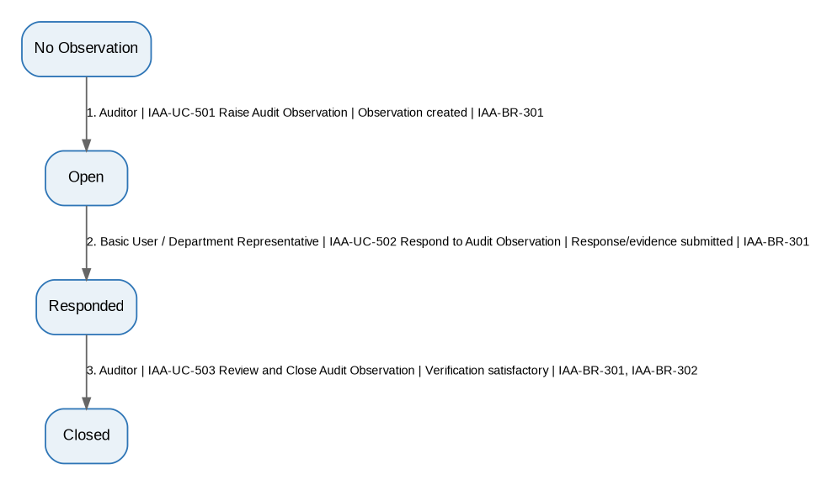
Editable source: 05A_IAA_Workflow_Diagrams_v1.3_FINAL.drawio, page BW-IAA-14. The diagram is generated from the authoritative STT above.

BW-IAA-15 - Audit Observation One Revision Traversal
Field | Specification
Workflow ID | BW-IAA-15
Workflow Name | Audit Observation One Revision Traversal
Type | Basis
Purpose / Scope | Representative one-traversal response-rework loop before audit-observation closure.
Trigger | Auditor finds the first response unsatisfactory.
Participants | Auditor; Basic User/Department Representative
Constituent Workflows | N/A
Related Workflows | CW-IAA-04
Related CFRs / key AFRs
Related UCs | IAA-UC-501, IAA-UC-502, IAA-UC-503
Related BRs | IAA-BR-301, IAA-BR-302
Traceability | See final CFR/AFR RTM for exact row-level requirement mapping. State-Transition Table below is authoritative.

Authoritative State-Transition Table
S. No. | From State | Actor | Use Case ID / Name | Guard / Outcome | Resulting State | BR Reference(s)
1 | No Observation | Auditor | IAA-UC-501 Raise Audit Observation | Observation created | Open | IAA-BR-301
2 | Open | Basic User / Department Representative | IAA-UC-502 Respond to Audit Observation | First response submitted | Responded | IAA-BR-301
3 | Responded | Auditor | IAA-UC-503 Review and Close Audit Observation | Verification unsatisfactory | Open | IAA-BR-301, IAA-BR-302
4 | Open | Basic User / Department Representative | IAA-UC-502 Respond to Audit Observation | Revised response submitted | Responded | IAA-BR-301
5 | Responded | Auditor | IAA-UC-503 Review and Close Audit Observation | Verification satisfactory | Closed | IAA-BR-301, IAA-BR-302

Workflow Diagram
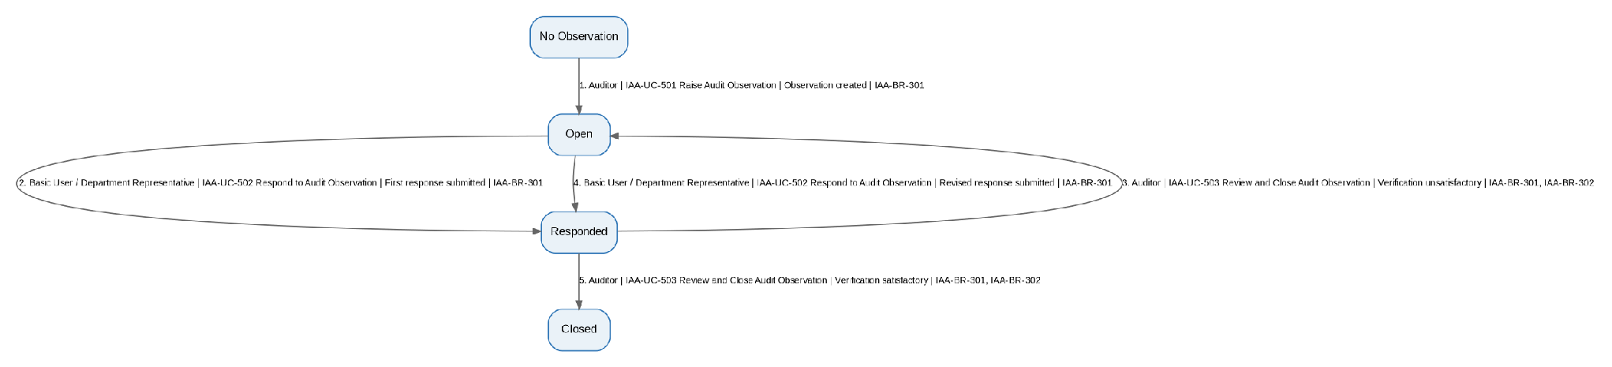
Editable source: 05A_IAA_Workflow_Diagrams_v1.3_FINAL.drawio, page BW-IAA-15. The diagram is generated from the authoritative STT above.

BW-IAA-16 - Escalated High-Value TA Approval
Field | Specification
Workflow ID | BW-IAA-16
Workflow Name | Escalated High-Value TA Approval
Type | Basis
Purpose / Scope | One timeout traversal from pending high-value TA approval to escalation, higher-authority approval, and recorded completion.
Trigger | Configured approval action time limit expires for a pending high-value TA authority decision.
Participants | System (automatic transition); Next/Higher Assigned Approving Authority; Finance Staff
Constituent Workflows | N/A
Related Workflows | BW-IAA-17; CW-IAA-02
Related CFRs / key AFRs
Related UCs | IAA-UC-203, IAA-UC-202, IAA-UC-404
Related BRs | IAA-BR-001, IAA-BR-002, IAA-BR-401, IAA-BR-005, IAA-BR-006, IAA-BR-503
Traceability | See final CFR/AFR RTM for exact row-level requirement mapping. State-Transition Table below is authoritative.

Authoritative State-Transition Table
S. No. | From State | Actor | Use Case ID / Name | Guard / Outcome | Resulting State | BR Reference(s)
1 | Approval Pending | System | IAA-UC-203 Escalate Overdue Approval | Pending authority action exceeds configured time limit | Escalated | IAA-BR-001, IAA-BR-002, IAA-BR-401
2 | Escalated | Next/Higher Assigned Approving Authority | IAA-UC-202 Handle Escalated Approval | Approved; no further approval level required | Approved | IAA-BR-001, IAA-BR-002, IAA-BR-005, IAA-BR-401
3 | Approved | Finance Staff | IAA-UC-404 Process & Record TA Request | Internal processing complete | Recorded | IAA-BR-006, IAA-BR-503

Workflow Diagram
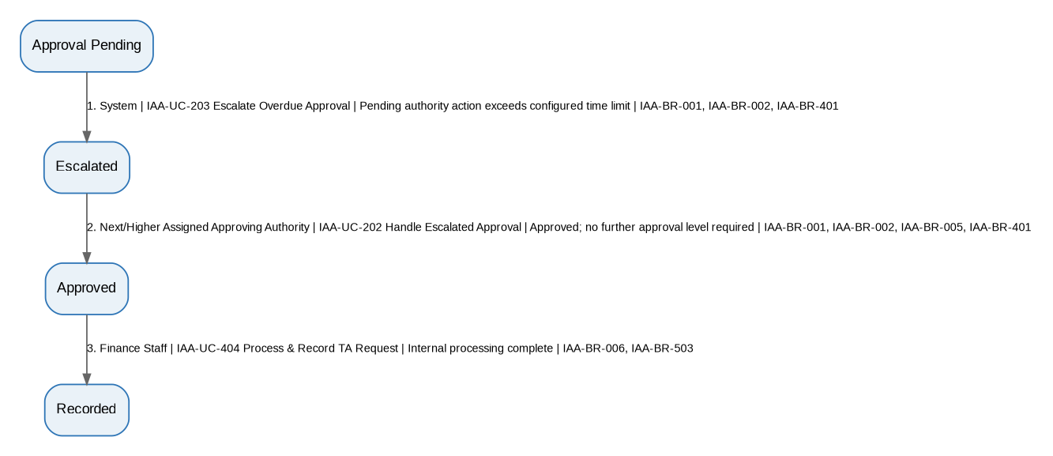
Editable source: 05A_IAA_Workflow_Diagrams_v1.3_FINAL.drawio, page BW-IAA-16. The diagram is generated from the authoritative STT above.

BW-IAA-17 - Escalated High-Value TA Rejection
Field | Specification
Workflow ID | BW-IAA-17
Workflow Name | Escalated High-Value TA Rejection
Type | Basis
Purpose / Scope | One timeout traversal from pending high-value TA approval to escalation and higher-authority rejection.
Trigger | Configured approval action time limit expires for a pending high-value TA authority decision.
Participants | System (automatic transition); Next/Higher Assigned Approving Authority
Constituent Workflows | N/A
Related Workflows | BW-IAA-16; CW-IAA-02
Related CFRs / key AFRs
Related UCs | IAA-UC-203, IAA-UC-202
Related BRs | IAA-BR-001, IAA-BR-002, IAA-BR-401, IAA-BR-005
Traceability | See final CFR/AFR RTM for exact row-level requirement mapping. State-Transition Table below is authoritative.

Authoritative State-Transition Table
S. No. | From State | Actor | Use Case ID / Name | Guard / Outcome | Resulting State | BR Reference(s)
1 | Approval Pending | System | IAA-UC-203 Escalate Overdue Approval | Pending authority action exceeds configured time limit | Escalated | IAA-BR-001, IAA-BR-002, IAA-BR-401
2 | Escalated | Next/Higher Assigned Approving Authority | IAA-UC-202 Handle Escalated Approval | Rejected with remarks | Rejected | IAA-BR-001, IAA-BR-002, IAA-BR-005, IAA-BR-401

Workflow Diagram
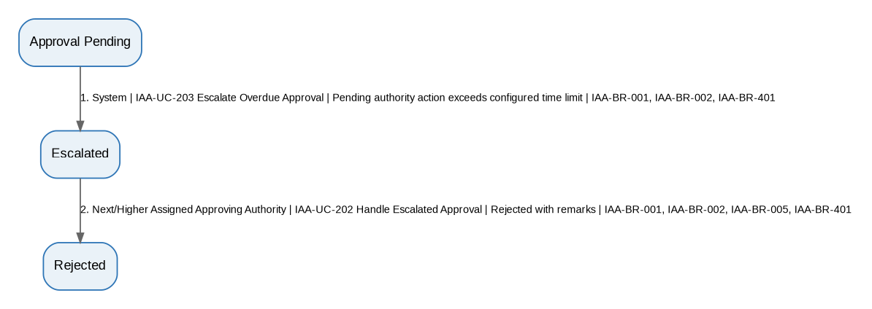
Editable source: 05A_IAA_Workflow_Diagrams_v1.3_FINAL.drawio, page BW-IAA-17. The diagram is generated from the authoritative STT above.

BW-IAA-18 - Automatic Anomaly Direct Resolution
Field | Specification
Workflow ID | BW-IAA-18
Workflow Name | Automatic Anomaly Direct Resolution
Type | Basis
Purpose / Scope | Configured automatic material-anomaly creation followed by direct resolution.
Trigger | Configured material anomaly condition becomes true.
Participants | System (automatic transition); Designated Anomaly Resolver
Constituent Workflows | N/A
Related Workflows | BW-IAA-19, BW-IAA-12, BW-IAA-13; CW-IAA-03
Related CFRs / key AFRs
Related UCs | IAA-UC-304, IAA-UC-303
Related BRs | IAA-BR-102, IAA-BR-103
Traceability | See final CFR/AFR RTM for exact row-level requirement mapping. State-Transition Table below is authoritative.

Authoritative State-Transition Table
S. No. | From State | Actor | Use Case ID / Name | Guard / Outcome | Resulting State | BR Reference(s)
1 | No Anomaly | System | IAA-UC-304 Create Automatic Anomaly | Configured material anomaly condition detected | Open | IAA-BR-102, IAA-BR-103
2 | Open | Designated Anomaly Resolver | IAA-UC-303 Resolve or Escalate Anomaly | Resolved | Resolved | IAA-BR-103

Workflow Diagram
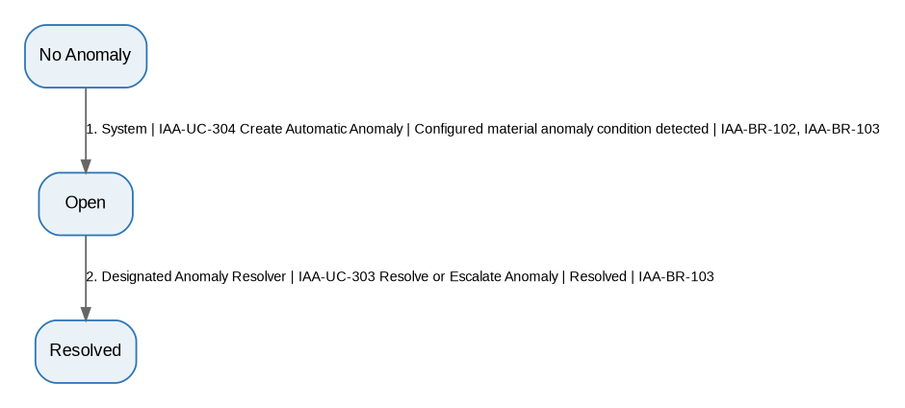
Editable source: 05A_IAA_Workflow_Diagrams_v1.3_FINAL.drawio, page BW-IAA-18. The diagram is generated from the authoritative STT above.

BW-IAA-19 - Automatic Anomaly One Escalation Traversal
Field | Specification
Workflow ID | BW-IAA-19
Workflow Name | Automatic Anomaly One Escalation Traversal
Type | Basis
Purpose / Scope | Configured automatic material-anomaly creation followed by one escalation traversal and resolution.
Trigger | Configured material anomaly condition becomes true and further resolution escalation is required.
Participants | System (automatic transition); Initial Resolver; Next Resolver
Constituent Workflows | N/A
Related Workflows | BW-IAA-18; CW-IAA-03
Related CFRs / key AFRs
Related UCs | IAA-UC-304, IAA-UC-303
Related BRs | IAA-BR-102, IAA-BR-103
Traceability | See final CFR/AFR RTM for exact row-level requirement mapping. State-Transition Table below is authoritative.

Authoritative State-Transition Table
S. No. | From State | Actor | Use Case ID / Name | Guard / Outcome | Resulting State | BR Reference(s)
1 | No Anomaly | System | IAA-UC-304 Create Automatic Anomaly | Configured material anomaly condition detected | Open | IAA-BR-102, IAA-BR-103
2 | Open | Initial Designated Resolver | IAA-UC-303 Resolve or Escalate Anomaly | Further escalation required | Escalated | IAA-BR-103
3 | Escalated | Next Designated Resolver | IAA-UC-303 Resolve or Escalate Anomaly | Resolved | Resolved | IAA-BR-103

Workflow Diagram
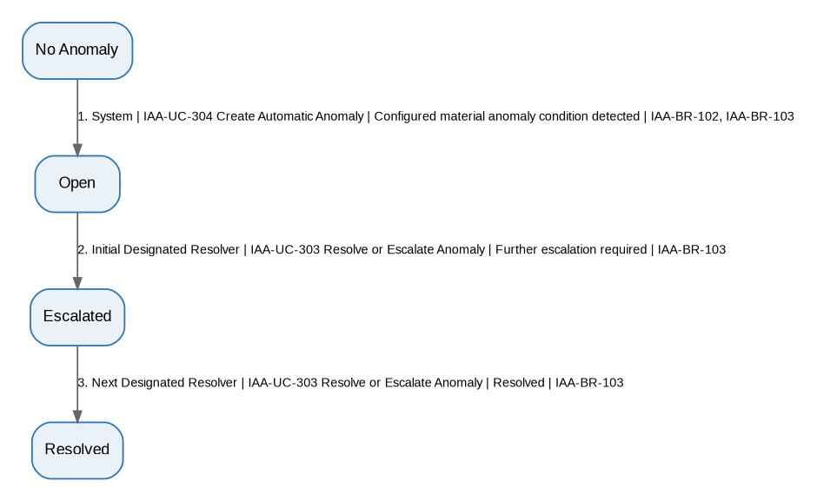
Editable source: 05A_IAA_Workflow_Diagrams_v1.3_FINAL.drawio, page BW-IAA-19. The diagram is generated from the authoritative STT above.

CW-IAA-01 - Expense/Voucher Lifecycle
Field | Specification
Workflow ID | CW-IAA-01
Workflow Name | Expense/Voucher Lifecycle
Type | Composite
Purpose / Scope | Integrates expense/voucher creation, Finance validation/clarification, configured approval, timeout escalation, rejection, and Finance record completion.
Trigger | Basic User creates/submits an expense/voucher request; timeout branch is event-triggered when applicable.
Participants | Basic User; Finance Staff; HoD; Dean; Director; System (timeout transition)
Constituent Workflows | BW-IAA-01 through BW-IAA-06
Related Workflows | CW-IAA-03 (separate anomaly lifecycle)
Related CFRs / key AFRs
Related UCs | IAA-UC-101, IAA-UC-102, IAA-UC-103, IAA-UC-104, IAA-UC-201, IAA-UC-203, IAA-UC-202, IAA-UC-105
Related BRs | IAA-BR-101, IAA-BR-104, IAA-BR-504, IAA-BR-102, IAA-BR-002, IAA-BR-001, IAA-BR-005, IAA-BR-401, IAA-BR-006, IAA-BR-503
Traceability | See final CFR/AFR RTM for exact row-level requirement mapping. State-Transition Table below is authoritative.

Authoritative State-Transition Table
S. No. | From State | Actor | Use Case ID / Name | Guard / Outcome | Resulting State | BR Reference(s)
1 | Not Created | Basic User | IAA-UC-101 Create Expense/Voucher Request | Save Draft | Draft | IAA-BR-101
2 | Draft | Basic User | IAA-UC-102 Submit Expense/Voucher Request | Submission complete | Submitted | IAA-BR-101, IAA-BR-104
3 | Submitted or Query Responded | Finance Staff | IAA-UC-103 Review & Validate Request | Clarification required | Query Raised | IAA-BR-504
4 | Query Raised | Basic User | IAA-UC-104 Respond to Finance Clarification Query | Response complete | Query Responded | IAA-BR-104
5 | Submitted or Query Responded | Finance Staff | IAA-UC-103 Review & Validate Request | Validation passes | Finance Validated | IAA-BR-102, IAA-BR-002
6 | Finance Validated or Approval Pending | Assigned Approving Authority | IAA-UC-201 Approve/Reject Request | Approved; further level required | Approval Pending | IAA-BR-001, IAA-BR-002, IAA-BR-005
7 | Finance Validated or Approval Pending | Assigned Approving Authority | IAA-UC-201 Approve/Reject Request | Approved; no further level required | Approved | IAA-BR-001, IAA-BR-002, IAA-BR-005
8 | Finance Validated or Approval Pending | Assigned Approving Authority | IAA-UC-201 Approve/Reject Request | Rejected | Rejected | IAA-BR-001, IAA-BR-005
9 | Finance Validated or Approval Pending | System | IAA-UC-203 Escalate Overdue Approval | Pending authority action exceeds configured time limit | Escalated | IAA-BR-001, IAA-BR-002, IAA-BR-401
10 | Escalated | Next/Higher Assigned Approving Authority | IAA-UC-202 Handle Escalated Approval | Approved; further level required or final approval | Approval Pending or Approved | IAA-BR-001, IAA-BR-002, IAA-BR-005, IAA-BR-401
11 | Escalated | Next/Higher Assigned Approving Authority | IAA-UC-202 Handle Escalated Approval | Rejected | Rejected | IAA-BR-001, IAA-BR-005, IAA-BR-401
12 | Approved | Finance Staff | IAA-UC-105 Process & Record Approved Request | Internal processing complete | Recorded | IAA-BR-006, IAA-BR-503

Workflow Diagram
Editable source: 05A_IAA_Workflow_Diagrams_v1.3_FINAL.drawio, page CW-IAA-01. The diagram is generated from the authoritative STT above.

CW-IAA-02 - TA Lifecycle
Field | Specification
Workflow ID | CW-IAA-02
Workflow Name | TA Lifecycle
Type | Composite
Purpose / Scope | Integrates TA submission, Finance verification/clarification, standard/high-value routing, approval timeout escalation, rejection, and Finance record completion.
Trigger | Eligible employee submits a TA claim; timeout branch is event-triggered when applicable.
Participants | Basic User (Employee); Finance Staff; HoD; Dean; Director; System (timeout transition)
Constituent Workflows | BW-IAA-07 through BW-IAA-11; BW-IAA-16; BW-IAA-17
Related Workflows | CW-IAA-03 (separate anomaly lifecycle)
Related CFRs / key AFRs
Related UCs | IAA-UC-401, IAA-UC-402, IAA-UC-104, IAA-UC-403, IAA-UC-203, IAA-UC-202, IAA-UC-404
Related BRs | IAA-BR-101, IAA-BR-104, IAA-BR-201, IAA-BR-504, IAA-BR-102, IAA-BR-202, IAA-BR-001, IAA-BR-002, IAA-BR-005, IAA-BR-401, IAA-BR-006, IAA-BR-503
Traceability | See final CFR/AFR RTM for exact row-level requirement mapping. State-Transition Table below is authoritative.

Authoritative State-Transition Table
S. No. | From State | Actor | Use Case ID / Name | Guard / Outcome | Resulting State | BR Reference(s)
1 | Not Submitted | Basic User (Employee) | IAA-UC-401 Submit TA Form | Submission valid | Submitted | IAA-BR-101, IAA-BR-104
2 | Submitted or Query Responded | Finance Staff | IAA-UC-402 Verify TA Form | Clarification required | Query Raised | IAA-BR-201, IAA-BR-504
3 | Query Raised | Basic User (Employee) | IAA-UC-104 Respond to Finance Clarification Query | Response complete | Query Responded | IAA-BR-104
4 | Submitted or Query Responded | Finance Staff | IAA-UC-402 Verify TA Form | Verified; no authority approval required | Verified | IAA-BR-102, IAA-BR-201, IAA-BR-202
5 | Submitted or Query Responded | Finance Staff | IAA-UC-402 Verify TA Form | Verified; authority approval required | Approval Pending | IAA-BR-102, IAA-BR-201, IAA-BR-202
6 | Submitted or Query Responded | Finance Staff | IAA-UC-402 Verify TA Form | Policy verification fails | Rejected | IAA-BR-201
7 | Approval Pending | Assigned Approving Authority | IAA-UC-403 Approve/Reject High-Value TA | Approved; further level required | Approval Pending | IAA-BR-001, IAA-BR-002, IAA-BR-005
8 | Approval Pending | Assigned Approving Authority | IAA-UC-403 Approve/Reject High-Value TA | Approved; no further level required | Approved | IAA-BR-001, IAA-BR-002, IAA-BR-005
9 | Approval Pending | Assigned Approving Authority | IAA-UC-403 Approve/Reject High-Value TA | Rejected | Rejected | IAA-BR-001, IAA-BR-005
10 | Approval Pending | System | IAA-UC-203 Escalate Overdue Approval | Pending authority action exceeds configured time limit | Escalated | IAA-BR-001, IAA-BR-002, IAA-BR-401
11 | Escalated | Next/Higher Assigned Approving Authority | IAA-UC-202 Handle Escalated Approval | Approved; further level required or final approval | Approval Pending or Approved | IAA-BR-001, IAA-BR-002, IAA-BR-005, IAA-BR-401
12 | Escalated | Next/Higher Assigned Approving Authority | IAA-UC-202 Handle Escalated Approval | Rejected | Rejected | IAA-BR-001, IAA-BR-005, IAA-BR-401
13 | Verified or Approved | Finance Staff | IAA-UC-404 Process & Record TA Request | Internal processing complete | Recorded | IAA-BR-006, IAA-BR-503

Workflow Diagram
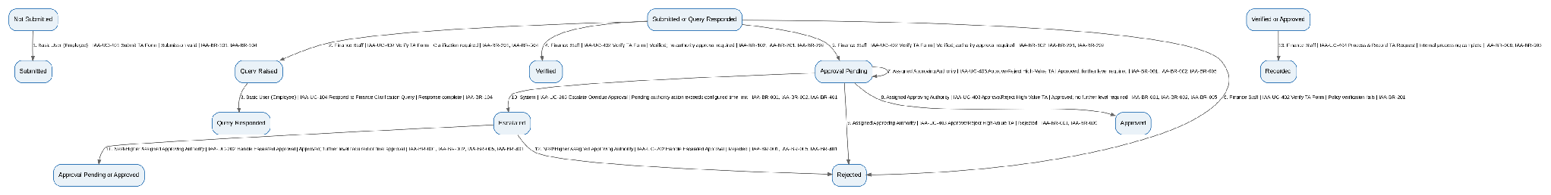
Editable source: 05A_IAA_Workflow_Diagrams_v1.3_FINAL.drawio, page CW-IAA-02. The diagram is generated from the authoritative STT above.

CW-IAA-03 - Anomaly Lifecycle
Field | Specification
Workflow ID | CW-IAA-03
Workflow Name | Anomaly Lifecycle
Type | Composite
Purpose / Scope | Integrates manual and configured automatic material-anomaly creation with direct resolution and one representative escalation traversal.
Trigger | Finance/Auditor manually flags an anomaly or a configured material anomaly condition becomes true.
Participants | Finance Staff; Auditor; Designated Anomaly Resolver(s); System (automatic creation transition)
Constituent Workflows | BW-IAA-12, BW-IAA-13, BW-IAA-18, BW-IAA-19
Related Workflows | CW-IAA-01, CW-IAA-02
Related CFRs / key AFRs
Related UCs | IAA-UC-302, IAA-UC-304, IAA-UC-303
Related BRs | IAA-BR-103, IAA-BR-102
Traceability | See final CFR/AFR RTM for exact row-level requirement mapping. State-Transition Table below is authoritative.

Authoritative State-Transition Table
S. No. | From State | Actor | Use Case ID / Name | Guard / Outcome | Resulting State | BR Reference(s)
1 | No Anomaly | Finance Staff or Auditor | IAA-UC-302 Flag Anomaly | Material anomaly manually confirmed | Open | IAA-BR-103
2 | No Anomaly | System | IAA-UC-304 Create Automatic Anomaly | Configured material anomaly condition detected | Open | IAA-BR-102, IAA-BR-103
3 | Open | Designated Anomaly Resolver | IAA-UC-303 Resolve or Escalate Anomaly | Resolved | Resolved | IAA-BR-103
4 | Open | Designated Anomaly Resolver | IAA-UC-303 Resolve or Escalate Anomaly | Escalation required | Escalated | IAA-BR-103
5 | Escalated | Next Designated Anomaly Resolver | IAA-UC-303 Resolve or Escalate Anomaly | Resolved | Resolved | IAA-BR-103

Workflow Diagram
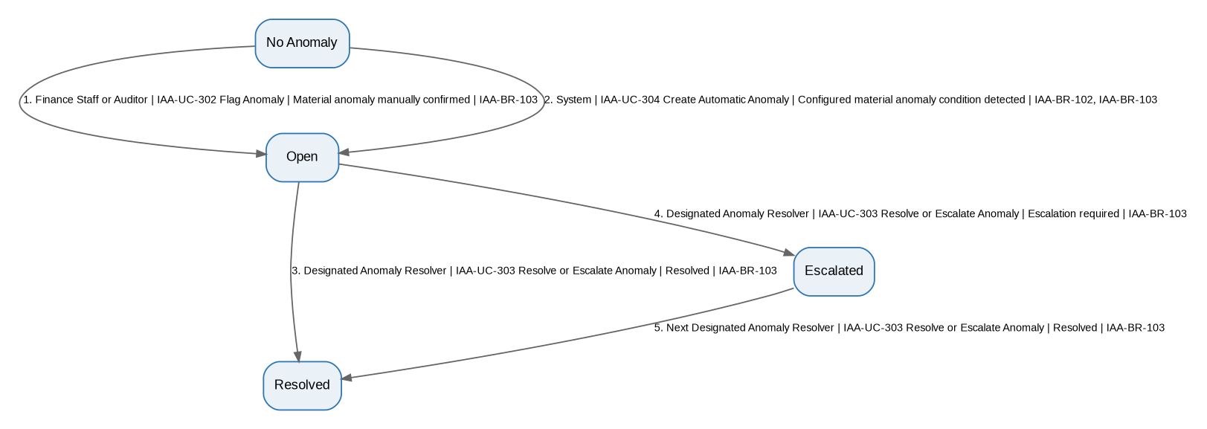
Editable source: 05A_IAA_Workflow_Diagrams_v1.3_FINAL.drawio, page CW-IAA-03. The diagram is generated from the authoritative STT above.

CW-IAA-04 - Audit Observation Lifecycle
Field | Specification
Workflow ID | CW-IAA-04
Workflow Name | Audit Observation Lifecycle
Type | Composite
Purpose / Scope | Integrates straight audit-observation closure and one representative response-revision traversal.
Trigger | Auditor raises an audit observation.
Participants | Auditor; Basic User/Department Representative
Constituent Workflows | BW-IAA-14, BW-IAA-15
Related Workflows | N/A
Related CFRs / key AFRs
Related UCs | IAA-UC-501, IAA-UC-502, IAA-UC-503
Related BRs | IAA-BR-301, IAA-BR-302
Traceability | See final CFR/AFR RTM for exact row-level requirement mapping. State-Transition Table below is authoritative.

Authoritative State-Transition Table
S. No. | From State | Actor | Use Case ID / Name | Guard / Outcome | Resulting State | BR Reference(s)
1 | No Observation | Auditor | IAA-UC-501 Raise Audit Observation | Observation created | Open | IAA-BR-301
2 | Open | Basic User / Department Representative | IAA-UC-502 Respond to Audit Observation | Response/evidence submitted | Responded | IAA-BR-301
3 | Responded | Auditor | IAA-UC-503 Review and Close Audit Observation | Verification satisfactory | Closed | IAA-BR-301, IAA-BR-302
4 | Responded | Auditor | IAA-UC-503 Review and Close Audit Observation | Verification unsatisfactory | Open | IAA-BR-301, IAA-BR-302

Workflow Diagram
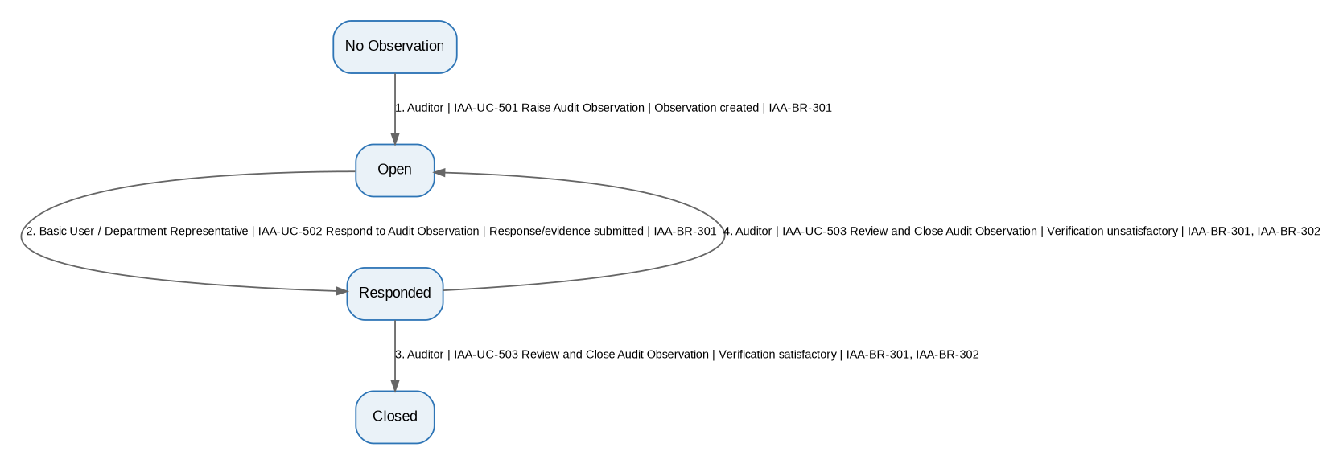
Editable source: 05A_IAA_Workflow_Diagrams_v1.3_FINAL.drawio, page CW-IAA-04. The diagram is generated from the authoritative STT above.

